VPC Challenge

Use Case: Setting up Transit Gateway and VPC Endpoints for a Multi-VPC Architecture
Scenario:
A large organization is migrating its on-premises infrastructure to the AWS cloud.
The organization's architecture involves multiple VPCs for different departments and applications, each requiring secure communication with centralized services and external resources.
The IT team needs to design and implement a scalable and efficient network architecture to accommodate the organization's growth and ensure robust connectivity between VPCs and external services.
Objectives:
Design and deploy a scalable network architecture using AWS Transit Gateway to simplify network connectivity between multiple VPCs.
Configure VPC endpoints to securely access AWS services without internet gateways or NAT gateways, ensuring data privacy and minimizing exposure to external threats

Part 1 — Prepare your VPCs
VPC-A
Name: Department-A-VPC
CIDR: 10.0.0.0/16
VPC-B
Name: Department-B-VPC
CIDR: 10.1.0.0/16
VPC-C
Name: Application-VPC
CIDR: 10.2.0.0/16
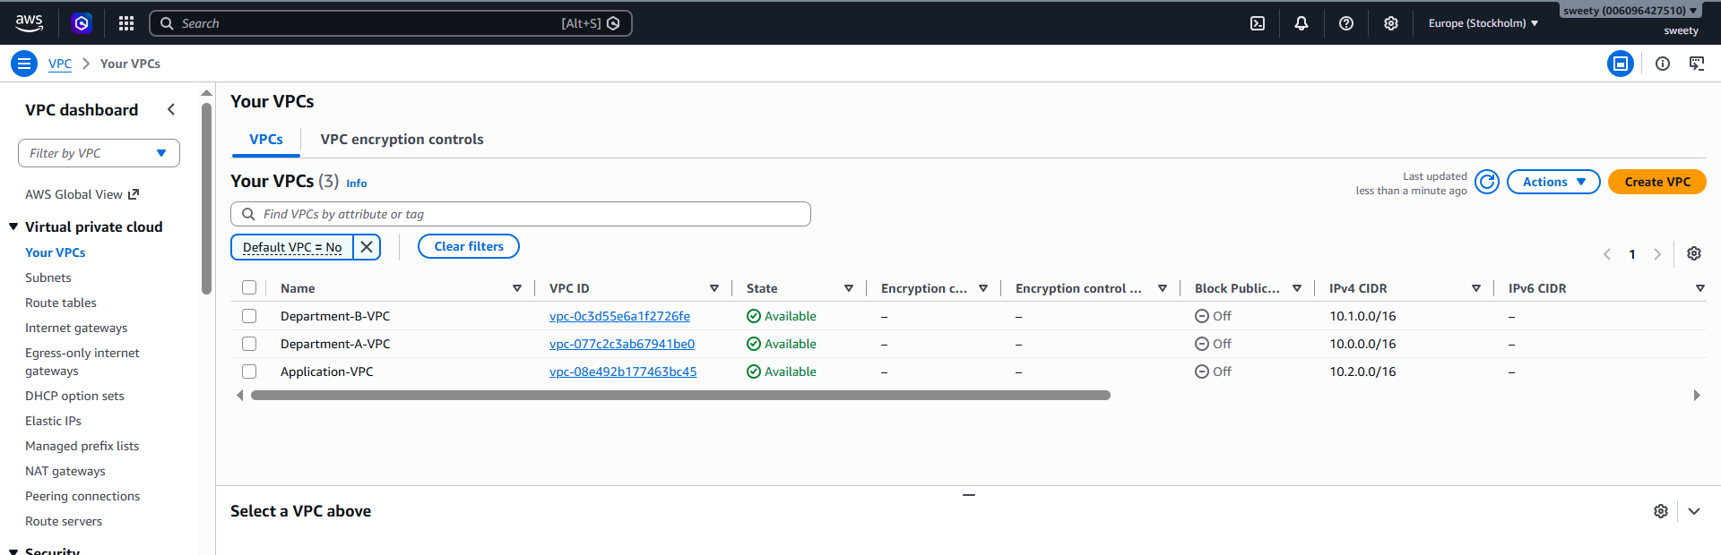

Part 2 — Create Transit Gateway
Go to:
AWS Console → VPC → Transit Gateways
Click:
Create transit gateway
Name tag: Organization-TGW
Description:
Central Transit Gateway for Multi-VPC Architecture
For the other settings, you can generally keep the defaults for this lab.
Then click:
Create transit gateway
Wait until the state becomes: Available
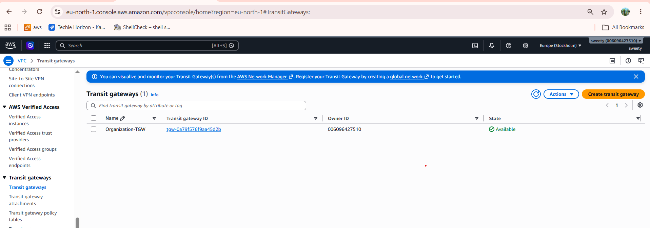

Part 3 — Create VPC attachments
Now we connect each VPC to the Transit Gateway.
Go to:
VPC → Transit Gateway Attachments
Click:
Create Transit Gateway attachment
Select:
Transit Gateway:
Organization-TGW
Then:
Attachment type:
VPC
Select:
VPC:
Department-A-VPC
Select the subnets in the VPC.
Create attachment

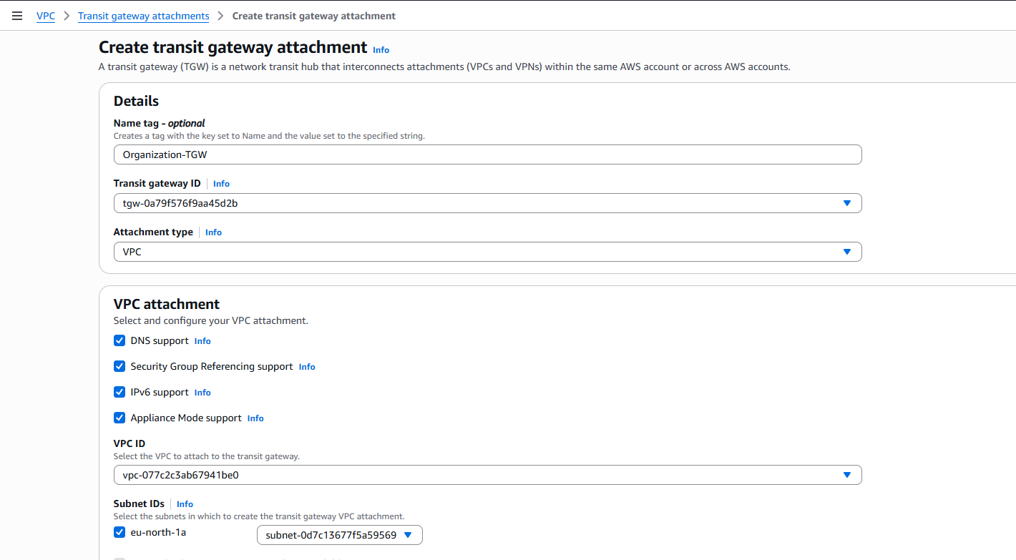

Repeat for VPC-B
Create another attachment:
Transit Gateway:
Organization-TGW
VPC:
Department-B-VPC
Subnets:
Private-Subnet-1
Private-Subnet-2

Repeat for VPC-C
Transit Gateway:
Organization-TGW
VPC:
Application-VPC

Subnets:
Private-Subnet-1
Private-Subnet-2
Wait for all attachments to become:
Available
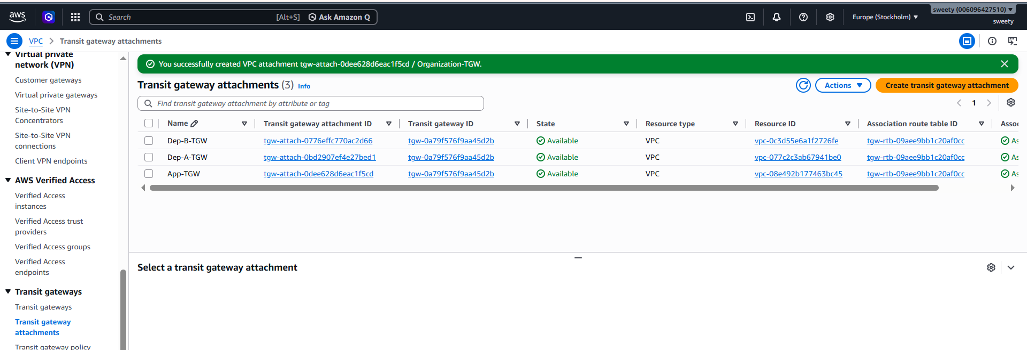

Part 4 — Configure Transit Gateway route table
This is a very important part.
Go to:
VPC → Transit Gateway Route Tables
Create a TGW route table if one wasn't automatically created.
For example:
Name:
Organization-TGW-RouteTable
Now associate the VPC attachments with this TGW route table.
You want:
TGW Route Table
|
+--- VPC-A attachment
+--- VPC-B attachment
+--- VPC-C attachment
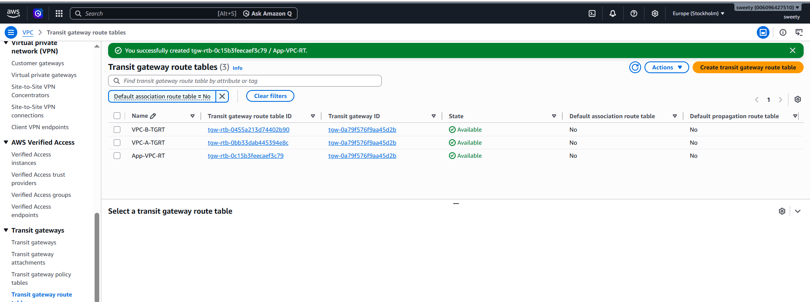

Part 5 — Add routes to VPC route tables
VPC-A → TGW → VPC-B
VPC-B → TGW → VPC-A
For VPC-A's private route table, add:
Destination: 10.1.0.0/16
Target: Transit Gateway
This means:
Traffic destined for VPC-B should go through the Transit Gateway.
If VPC-A needs to communicate with VPC-C, add:
Destination: 10.2.0.0/16
Target: Transit Gateway

VPC-B private route table
Add:
Destination: 10.0.0.0/16
Target: Transit Gateway
and:
Destination: 10.2.0.0/16
Target: Transit Gateway

VPC-C private route table
Add:
Destination: 10.0.0.0/16
Target: Transit Gateway
and:
Destination: 10.1.0.0/16
Target: Transit Gateway

Part 6 — Configure VPC Endpoints
The purpose is:
Allow resources in private subnets to communicate with AWS services without needing an Internet Gateway or NAT Gateway
EC2
|
Private Subnet
|
VPC Endpoint
|
AWS S3

Part 7 — Create S3 Gateway Endpoint
This is the easiest endpoint to demonstrate.
Go to:
VPC → Endpoints
Click:
Create endpoint
Choose:
Type:
AWS services
For service category, select:
AWS services
Find:
S3
Choose the S3 service.

For endpoint type, choose:
Gateway
Select your VPC.

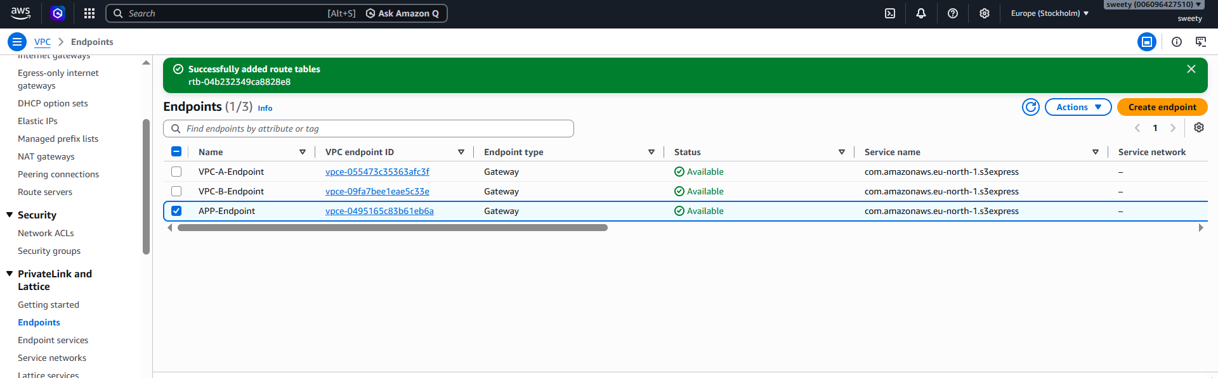

Part 8 — Create an Interface Endpoint
You can also demonstrate an Interface VPC Endpoint.
This is useful for services such as:
- AWS Systems Manager
- CloudWatch
- CloudWatch Logs
- EC2 API
- ECR
- Secrets Manager
For a simple lab, you could create:
com.amazonaws.us-west-1.ssm
if you are working in us-west-1.
Go to:
VPC → Endpoints → Create endpoint
Choose:
AWS services
Search for:
SSM
Select:
com.amazonaws.<region>.ssm
For example:
com.amazonaws.us-west-1.ssm
Choose:
Type:
Interface
Select your VPC:
Department-A-VPC
Select the private subnets.
For example:
Private-Subnet-1
Private-Subnet-2
Select/create a security group that allows HTTPS:
Inbound:
HTTPS
Port: 443
Source: VPC CIDR
For example:
10.0.0.0/16
Then create the endpoint.
Part 10 — Test Transit Gateway connectivity
You need to prove that the TGW is actually working.
Launch an EC2 instance in:
VPC-A private subnet
and another EC2 instance in:
VPC-B private subnet
For testing, you can use private IP addresses.
For example:
VPC-A EC2:
10.0.1.10

VPC-B EC2:
10.1.1.10
From VPC-A:
ping 10.1.1.10
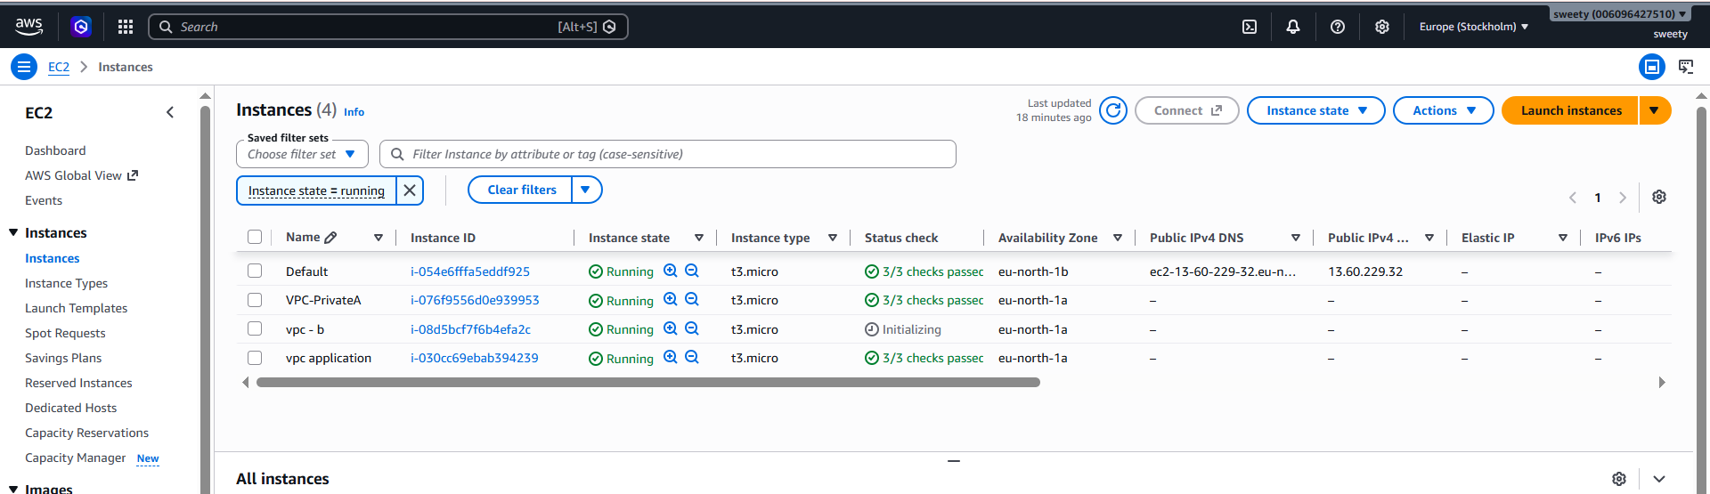

Part 11 — Test the S3 VPC Endpoint
From an EC2 instance in a private subnet, run:
aws s3 ls

Part 12 — Security Groups
Make sure your security groups allow the traffic you are testing.
For example, if VPC-A EC2 needs to access VPC-B EC2 over HTTP:
VPC-B EC2 Security Group
Inbound

Type: HTTP
Port: 80
Source: 10.0.0.0/16
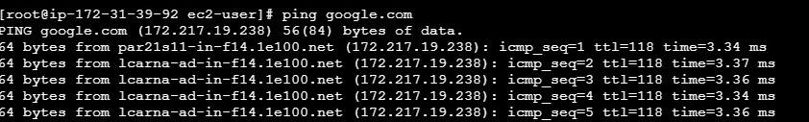

VPC-A Private ip: 10.0.4.41
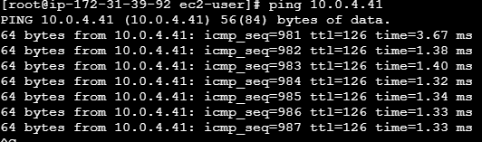

VPC -B Private ip:10.1.225.33
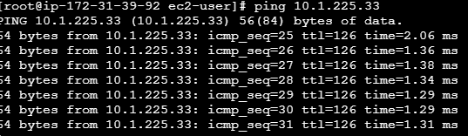
VPC- application private ip:10.2.191.108
